 |  | JURONG JUNIOR COLLEGE  JC 2 PRELIMINARY EXAMINATION  Higher 1
CHEMISTRY |  |  | 8872/01
Paper 1 Multiple Choice |  |  | 3 September 2010
 |  |  | 50 minutes
Additional Materials: Multiple Choice Answer Sheet
Data Booklet

READ THESE INSTRUCTIONS FIRST

Write in soft pencil.
Do not use staples, paper clips, highlighters, glue or correction fluid.
Write your name, class and shade your exam number on the Answer Sheet in the spaces provided.

There are thirty questions on this paper. Answer all questions. For each question there are four possible answers A, B, C and D.
Choose the one you consider correct and record you choice in soft pencil on the separate Answer Sheet.

Read the instructions on the Answer Sheet very carefully.

Each correct answer will score one mark. A mark will not be deducted for a wrong answer.
Any rough working should be done in this booklet.

A Data Booklet is provided. Do not write anything on the Data Booklet.

This document consists of 13 printed pages.
[Turn over
SECTION A

For each question there are four possible answers, A, B, C and D. Choose the one you consider to be correct.

1. | Mass spectrometry (MS) is an analytical technique for the determination of the elemental composition of a sample. The MS principle consists of ionising chemical compounds to generate charged fragments and measure the mass–to–charge ratios (m/e) of isotopes.  The m/e value corresponds to the relative atomic mass of the elemental isotopes.  Element X has two isotopes, ⁶³X and ⁶⁵X, and the graph below shows the mass spectrum of element X obtained by mass spectrometry.  % abundance  m/e  10  20  30  40  50  60  70  61 62 63 64 65 66  What is the relative atomic mass of element X?
 | A | 63.3 | B | 63.4 | C | 63.5 | D | 63.6

2. | Calcium sulfate occurs naturally as gypsum, CaSO₄•2H₂O. When heated to 160°C, gypsum loses some of its water of crystallisation to give plaster of Paris which is used for making fine plaster casts and for setting broken limbs.  During the heating process, 100 g of gypsum loses 15.7 g of water according the equation below:  CaSO₄•2H₂O 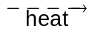 CaSO₄•(2 – n)H₂O + nH₂O  gypsum plaster of Paris  What is the formula of plaster of Paris?
 | A | 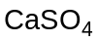 | C | 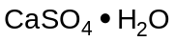
 | B | 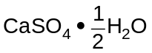 | D | 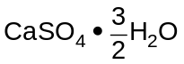

3. | TNT is used as an explosive and it has the structure as shown below.  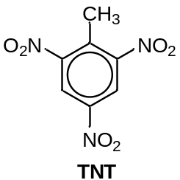  It can decompose according to the following equation :  2 TNT 7CO(g) + 7C(s) + 5H₂O(g) + 3N₂(g)  What volume of gas will be produced when 10 g of TNT is completely decomposed at 400°C and 1 atm?  It is given that the molar volume of gas at 400°C and 1 atm is 55 dm³.
 | A | 9.1 dm³ | B | 9.7 dm³ | C | 18.2 dm³ | D | 36.4 dm³

4. | The successive ionisation energies of two elements, W and Y, are given below:  What is the formula of the compound that W and Y are likely to form?
   | ionisation energies in kJ mol^{–1}
  element | 1st | 2nd | 3rd | 4th | 5th | 6th | 7th | 8th
  W | 578 | 1817 | 2745 | 11577 | 14842 | 18379 | 23326 | 27465
  Y | 1314 | 3388 | 5301 | 7469 | 10990 | 13327 | 71330 | 84078
 | A | WY₄ | B | W₂Y₄ | C | W₃Y₂ | D | W₂Y₃

5. | Which of the following statements describes a phenomenon which cannot be explained by intermolecular hydrogen bonding?
 | A | Ice has a lower density than water at 0°C.
 | B | Propanone is more volatile than propan–2–ol.
 | C | Ethanoic acid vapour has a relative molecular mass of 120 instead of 60.
 | D | The boiling point of alcohols decreases with increasing branching of carbon chain.

6. | What is the shape of SF₄ molecule?
 | A | square | C | see–saw
 | B | trigonal pyramidal | D | tetrahedral

7. | Which of the following statements explain why calcium sulfide has a higher melting point than sodium fluoride?
 | A | Charge density of Ca²⁺ is greater than that of Na⁺.
 | B | Size of electron cloud of S^{2–} is larger than that of F–.
 | C | More energy is required to form Ca²⁺ from Ca than to form Na⁺ from Na atom.
 | D | The electrostatic force of attraction between doubly charged ions is stronger.

8. | Which of the following statements about ammonia is true?
 | A | Ammonia forms ionic bond with H⁺ to produce ammonium ion.
 | B | Covalent bonds between nitrogen and hydrogen atoms in ammonia are overcome during boiling.
 | C | Ammonia reacts with hydrochloric acid to give a salt solution which turns Universal Indicator yellow.
 | D | In aqueous ammonia, the only species present are simple molecules with hydrogen bonding between them.

9. | The reduction of ethanal to ethanol using H₂(g) is shown in the equation below:  CH₃CHO(l) + H₂(g) CH₃CH₂OH(l)  ethanal ethanol  Given the values for the enthalpy change of combustion of ethanal, hydrogen and ethanol, what is the enthalpy change of reaction?
  substance | ∆H_{c} /kJ mol^{–1}
  ethanal | –1170
  hydrogen | –286
  ethanol | –1370
 | A | +86 kJ mol^{–1} | B | –86 kJ mol^{–1} | C | –2826 kJ mol^{–1} | D | +2826 kJ mol^{–1}

10. | The following equilibria is subjected to an increase in volume at constant temperature.  For which equilibrium will the change result in an increase in the proportion of products?
 | A | H₂(g) + I₂(g)  2HI(g)
 | B | N₂(g) + 3H₂(g)  2NH₃(g)
 | C | 4NH₃(g) + 5O₂(g)  4NO(g) + 6H₂O(g)
 | D | 2HBr(g) + H₂SO₄(l)  Br₂(g) + SO₂(g) + 2H₂O(l)
11. | A 1 mol sample of a monobasic weak acid, CH₃COOH, is diluted at constant temperature to a volume V.  CH₃COOH(aq) + H₂O(l)  CH₃COO–(aq) + H₃O⁺(aq)  Which of the following graphs correctly illustrates the relationship between V and the acid dissociation constant, K_{a}, of CH₃COOH?
 | A | K_{a}  0  V | C | K_{a}  0  V
 | B | K_{a}  0  V | D | K_{a}  0  V

12. | Ethyl ethanoate is synthesised industrially via the classic Fischer esterification reaction of ethanol and ethanoic acid as shown in the equation below. This mixture converts to the ester in about 65 % yield at room temperature.  CH₃COOH(l) + CH₃CH₂OH(l)  CH₃COOCH₂CH₃ (l) + H₂O(l)  4 mol each of ethanoic acid and ethanol were put into a 1 dm³ container. The mixture was heated and cooled to reach equilibrium at room temperature.  What is the numerical value of the equilibrium constant, K_{c}, at room temperature?
 | A | 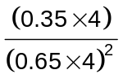 | B | 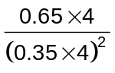 | C | 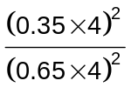 | D | 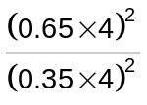

13. | Consider the hypothetical reaction :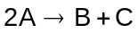.  Given that the rate constant, k, of the reaction is 0.156 s^{–1}, which of the following graphs correctly reflects the reaction kinetics of the reaction?
 | A | Rate  [A]  0 | C | Rate  [A]  0
 | B | Rate  [A]  0 | D | Rate  [A]  0

14. | Iodine–131 is a radioactive isotope with a half–life of 8 days. Following the nuclear power plant disaster at Chernobyl in 1986, it was stated that the situation would become safe only when 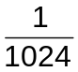of the iodine–131 isotopes remained in the cloud of vapour formed.  Given that the radioactive decay is a first–order reaction, how long would it take for the situation to become safe?
 | A | 1024 days | B | 80 days | C | 72 days | D | 40 days

15. | Which of the following graphs correctly explains an increase in rate of reaction when the temperature of reaction increases from T₁ to T₂?
 | A | fraction of particles  0  energy  E_{a}  T₂  T₁ | C | fraction of particles  0  energy  E_{a}  T₂  T₁
 | B | fraction of particles  0  energy  E_{a}  T₂  T₁ | D | fraction of particles  0  energy  E_{a}  T₁  T₂

16. | The table gives data for the reaction between D and E at constant temperature.  What is the rate equation for the reaction?
  Experiment | [D] /mol dm^{–3} | [E] /mol dm^{–3} | Initial rate /mol dm^{–3} s^{–1}
  1 | 0.055 | 0.33 | 1.5 × 10^{–3}
  2 | 0.110 | 0.33 | 6.0 × 10^{–3}
  3 | 0.110 | 0.16 | 6.0 × 10^{–3}
 | A | 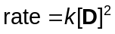 | C | 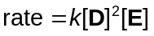
 | B | 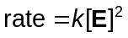 | D | 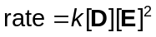

17. | The graph below shows the ionic radii of seven elements found in Period 3.  ionic radius  element  Na Mg Al Si P S Cl  Which of the following statements correctly explains the trends shown in the graph?
 | A | The ionic radius of P^{3–} ion is greater than that of Si⁴⁺ ion due to greater mutual repulsion between electrons.
 | B | The ionic radius decreases from Na⁺ ion to Si⁴⁺ ion due to decreasing shielding effect by inner shell electrons.
 | C | The ionic radius decreases from Na⁺ ion to Si⁴⁺ ion due to decreasing nuclear charge.
 | D | The ionic radius decreases from P^{3–} ion to Cl– ion due to increasing nuclear charge.

18. | P, Q and R are main group elements in the same period of the Periodic Table. The oxide of P is basic, the oxide of Q is acidic and the oxide of R is amphoteric.  What is the order of increasing atomic number for these elements, starting from the lowest?
 | A | P < Q < R
 | B | P < R < Q
 | C | Q < R < P
 | D | R < P < Q

19. | Limonene is an oil formed in the peel of citrus fruits. It has the structure as shown below.  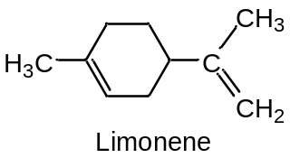  How many geometric isomer(s) does limonene possess?
 | A | 0 | B | 2 | C | 4 | D | 6

20. | The structures of four organic compounds S, T, U and V are given below.  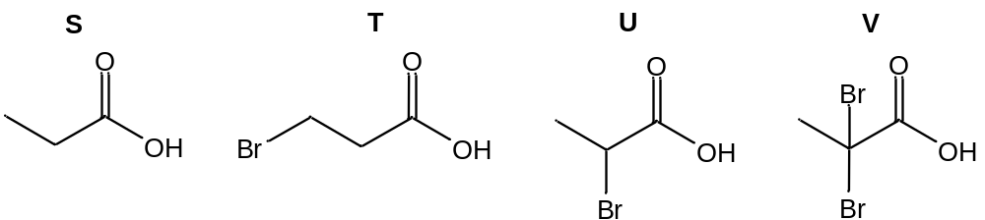  Which of the following correctly gives the K_{a} of the four compounds in decreasing order?
 |  | highest |  |  | lowest
 | A | S | T | U | V
 | B | U | T | V | S
 | C | S | V | U | T
 | D | V | U | T | S

21. | The structures of three halogen–containing organic compounds, E, F and G, are shown below.  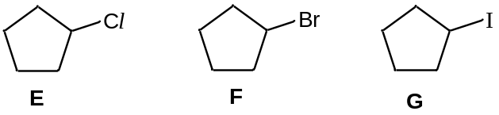  In which order will the precipitate of respective silver halides be formed when hot sodium hydroxide is added to E, F and G, followed by acidified silver nitrate solution?
 |  | fastest |  | slowest
 | A | G | E | F
 | B | E | F | G
 | C | G | F | E
 | D | F | G | E

22. | Ibuprofen is used for the relief of symptoms of arthritis and fever, and also as an analgesic. It has the chemical structure as shown below.  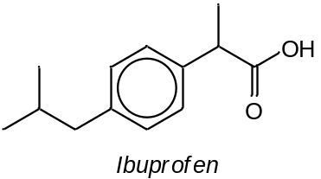  Which of the following proposed route would be the most appropriate for the synthesis of Ibuprofen in laboratory?  (The alkyl group 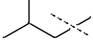can be simplified as R.)
 | A | 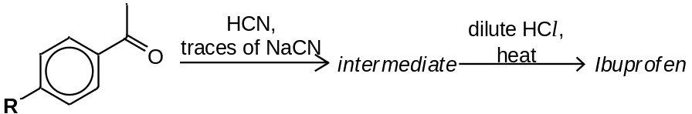
 | B | 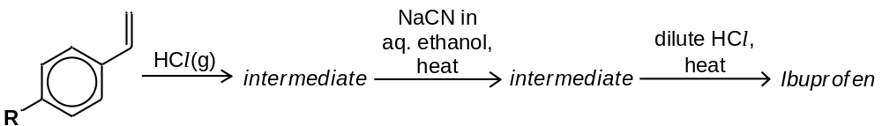
 | C | 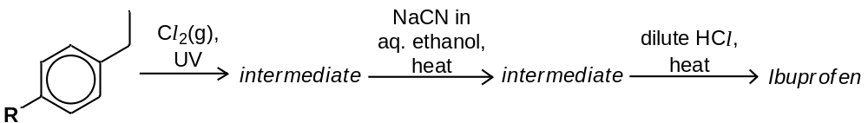
 | D | 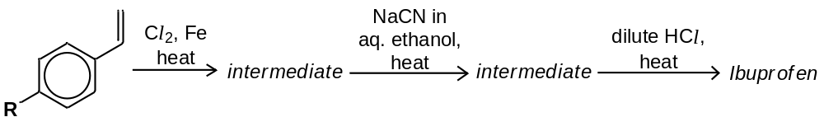

23. | An ester, C₄H₈O₂, undergoes the following reactions :  - reacts with hot H₂SO₄(aq) to give carboxylic acid H and alcohol J  - alcohol J reacts with hot alkaline I₂(aq) to give pale yellow precipitate  - carboxylic acid H reacts with LiAlH₄ in dry ether to give alcohol J  Which of the following could be the structure of the ester?
 | A | CH₃COOCH₂CH₃ | C | HCOOCH(CH₃)₂
 | B | CH₃CH₂COOCH₃ | D | HCOOCH₂CH₂CH₃

24. | Phenol is a class of hydroxy–containing compound with the –OH group attached to a benzene ring. It is a stronger acid than ethanol but a weaker acid than ethanoic acid.  An organic compound X has the following structure as shown below.  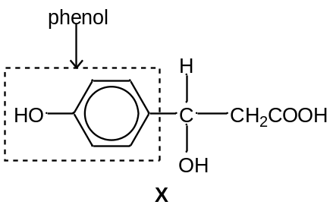  How many moles of hydrogen gas will be formed when 2 mol of X is reacted with sodium metal?
 | A | 3 mol | B | 2 mol | C | 1 mol | D | 0 mol

25. | Which of the following reactions would produce |  | 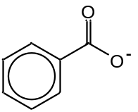 | ?
 | A | 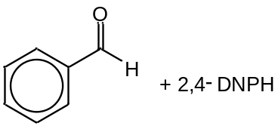
 | B | 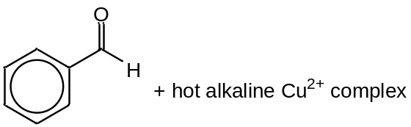
 | C | 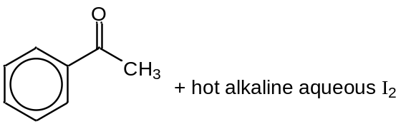
 | D | 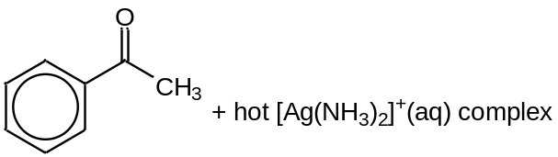
SECTION B

For each of the questions in this section, one or more of the three numbered statements 1 to 3 may be correct.

Decide whether each of the statements is or is not correct.

The responses A to D should be selected on the basis of

A | B | C | D
1, 2 and 3 are  correct | 1 and 2 only are  correct | 2 and 3 only are  correct | 1 only is  correct

No other combination of statements is used as a correct response.

26. | An element L, found in Period 3, is a good conductor of electricity in solid and liquid state. It also reacts violently with water and oxygen.  Which of the following statements are true about element L?
 | 1 | L has a giant metallic structure.
 | 2 | The oxide of L reacts with alkali but not acid.
 | 3 | The mobile charged carriers of L in solid state are ions and electrons.

27. | The chloride of an element G, where G is found in Period 3, is a liquid which has a boiling point of 76°C and fumes in air.  100 cm³ of 0.30 mol dm^{–3} silver nitrate is required for the complete precipitation of the chloride ion in the resulting solution when 0.010 mol of the chloride is mixed with water.  Which of the following statements are true about element G?
 | 1 | Element G belongs to Group III of the Periodic Table.
 | 2 | The oxide of G is a solid under standard conditions.
 | 3 | The chloride of G turns Universal Indicator red when dissolved in water.

28. | Which of the following reagents and conditions can distinguish ethanol (CH₃CH₂OH) and ethanal (CH₃CHO)?
 |  | 1 | alkaline Cu²⁺ complex solution, heat
 |  | 2 | hot [Ag(NH₃)₂]⁺ solution
 |  | 3 | 2,4–dinitrophenylhydrazine

A | B | C | D
1, 2 and 3 are  correct | 1 and 2 only are  correct | 2 and 3 only are  correct | 1 only is  correct

29. | Benzil, which has the structure shown below, is commonly employed as a photoinitiator for free–radical curing of polymer network. Ultraviolet radiation decomposes benzil, creating free–radical species which propagate throughout polymer material.  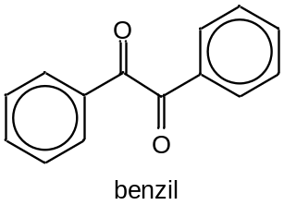  Which of the following statements are true about benzil?
 | 1 | It is a non–polar molecule.
 | 2 | It can be synthesised by reacting | 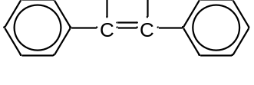 | with cold, alkaline KMnO₄
 |  | followed by hot acidified K₂Cr₂O₇.
 | 3 | It does not give orange–yellow crystals upon reaction with 2,4–DNPH.

30. | Smoke from a bonfire contains a compound that causes irritation to the eyes. It has the following properties:  - gives white fumes with phosphorous pentachloride;  - decolourises hot acidified purple KMnO₄;  - decolourises aqueous bromine readily.  What are the possible structures of the compound?
 |  | 1 | 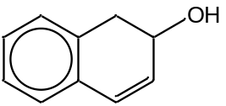
 |  | 2 | 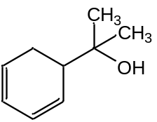
 |  | 3 | 